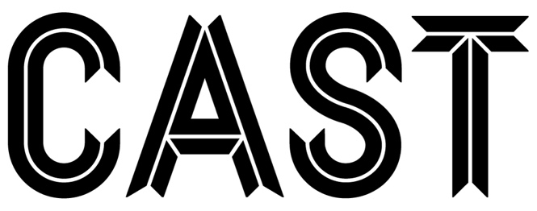

Board Chair
Recruitment Pack 2026

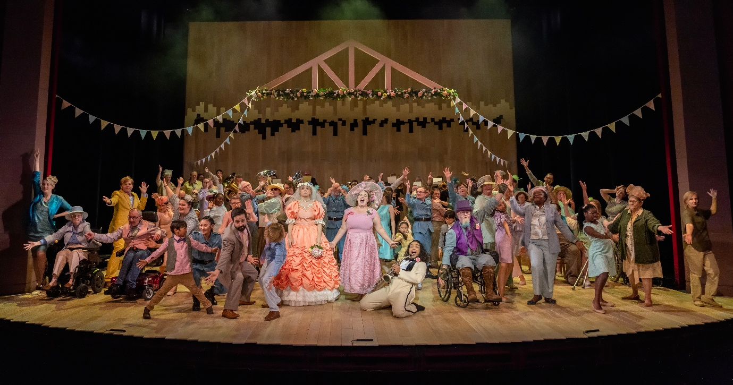The Doncastrian Chalk Circle © Ant Robling 2022
Introduction
Thank you for your interest in the role of Board Chair Designate. Cast is looking for an experienced, senior leader to lead our Board of Trustees and oversee the governance and evolution of the charity.
The main purpose of the Trustees is to ensure that Cast operates effectively and equitably, within the parameters of its charitable objectives to further its strategy. The Board provides oversight, support, challenge, scrutiny, advocacy and new connections that help us extend Cast’s impact beyond its day-to-day operations. It operates on a voluntary basis, meeting every three months bringing a range of skills, knowledge and experience to bear.
In 2026, Cast appointed Director James Blakey to lead Cast. James leads a Senior Management Team that includes a newly appointed Head of Creative Programme and new Technical Director. Cast is in a phase of strategic review with preparation for a five year business plan (2027-2032) running alongside the Arts Council National Portfolio Organisation (NPO) funding period. Meanwhile the organisation maintains a busy, vibrant programme of activity with over 300 shows presented this year including an in-house produced pantomime Dick Whittington and a Doncaster People’s Theatre production of Waiting in the Wings, a revitalised talent development programme and sector-leading participatory offer. We are looking for a Board Chair to oversee this exciting period of both ambitious delivery and organisational development.
In this pack we’ve outlined what sort of people we’re looking for alongside more information about the role Trustees play and about Cast in general. We welcome applications from candidates with senior leadership experience from any sector or professional background who is aligned with our values and inspired to give their time in the service of our mission. We particularly encourage applications from those who are under-represented in senior roles in arts and cultural organisations.

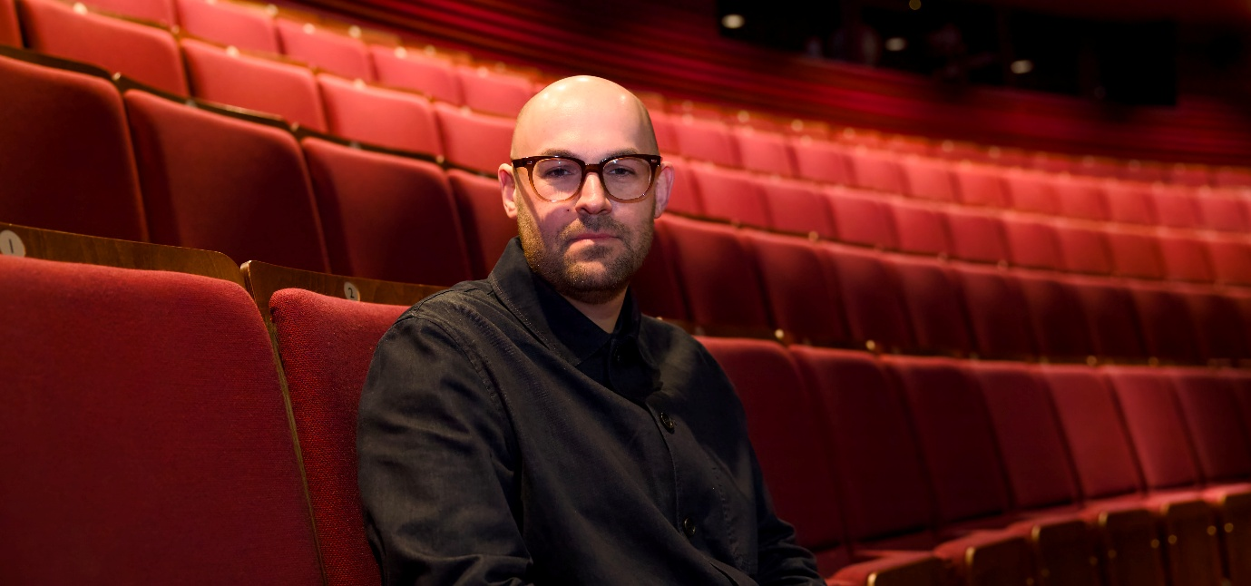James Blakey, Director
About Us
Vision
We believe in the creative potential of every individual and the transformative power of engagement with the arts. Cast’s work will enrich lives and inspire the people of Doncaster and the wider region, contributing to vibrant and creative communities.
Mission
To enrich the creative and cultural lives of our communities through high-quality and engaging artistic experiences.
Values
We Welcome Everybody and strive to Do the Right Thing, so that we can Create Culture Together and Make a Difference.
Cast launched in 2013 as the anchor of the Cultural and Civic Quarter. In a short time we have become a much-loved part of life in Doncaster, presenting world class theatre, dance, music, comedy, outdoor performances and early years work, ensuring inclusive access through community engagement activities and supporting the development of artists regionally and nationally. We like to dream big and bring ambitious ideas into reality, experiment and challenge ourselves and break down barriers so that everyone can access the arts. We present bold, imaginative work and offer entertaining nights out.

Over 120,000 people attend over 300 performances at Cast each year in our 620 seat main-house, flexible studio theatre and public spaces such as Sir Nigel Greasley Square. Our facilities also include dance and drama ‘making spaces’, a range of meeting spaces and café/bar. Our participation programme creates meaningful opportunities for people of all ages, backgrounds and bodies from across the borough to get involved in creative activities, ambitious performance projects and pathways into the creative industries.

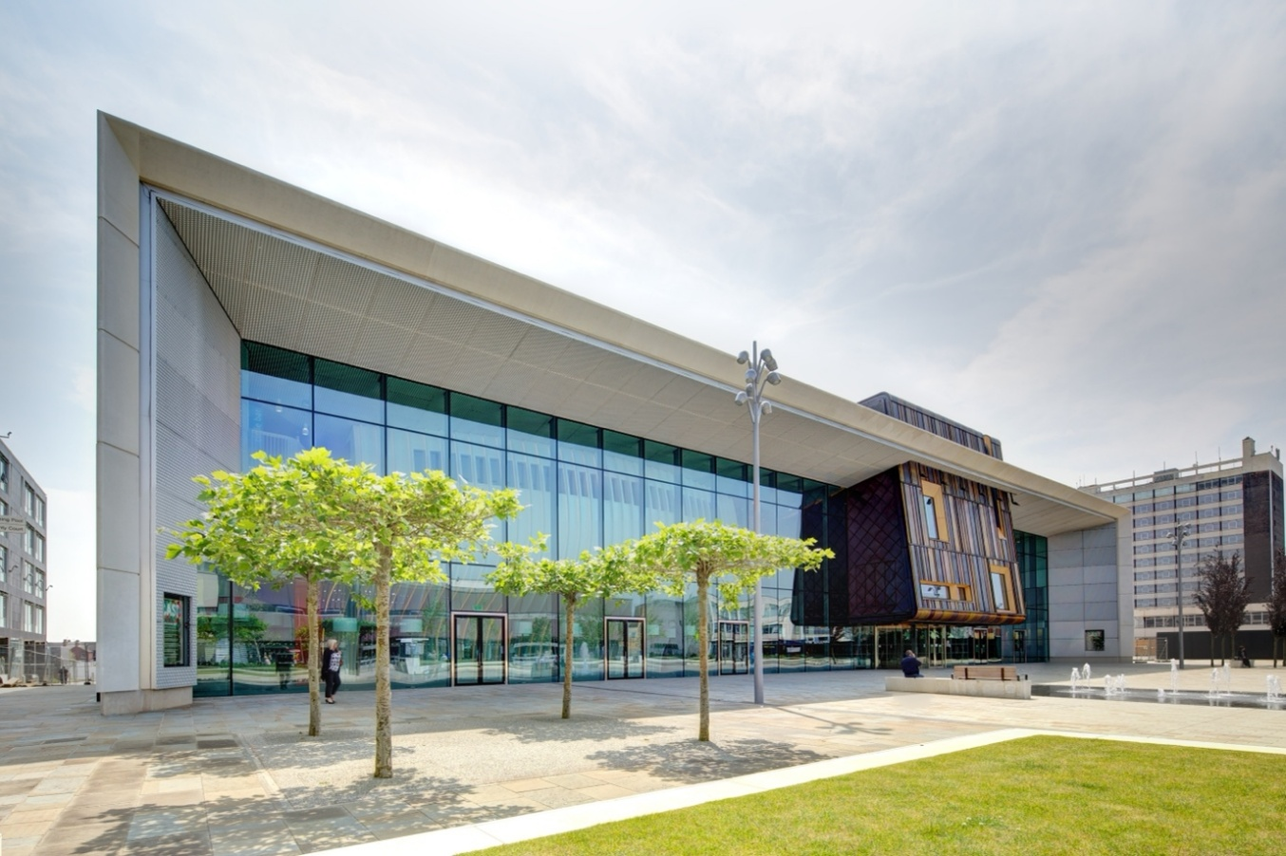
Over 300 locals actively involved in participation projects come through our doors every week and we run neighbourhood-sited projects with partners in the borough. Welcoming Everybody is one of our key values. We are proud of our access provision and Theatre of Sanctuary status and we continually reflect on our practice with advisory groups including our Youth Board, Community Board and Access Focus Group.
Cast is a company limited by guarantee. We are funded by the Arts Council of England as one of their National Portfolio Organisations. We receive a venue management fee from the City of Doncaster Council, who own the Cast building, as well as organisational support from our parent company – Doncaster Culture and Leisure Trust (DCLT). DCLT, who run cultural and leisure facilities throughout the borough also houses Right Up Our Street (Doncaster’s Creative People and Places organisation) and the Social Isolation and Loneliness Alliance. DCLT is a charity with its own Board of Directors and some of these Board members also sit on the Cast Board. Cast staff are seconded from DCLT who acts as the employer organisation. As such, workers at Cast are subject to DCLT terms, policies and procedures. However, Cast remains an autonomous charity in its own right with its own Trustees and legal responsibilities.
Together with these key strategic partners and other stakeholders, the Board of Trustees and our hardworking staff team, we are the custodians of this fabulous arts centre for Doncaster.
"Cast has achieved so much in its first ten years and I am proud to have watched it grow. The team has created so many opportunities for the people of Doncaster to experience brilliant performances on stage, including great drama from local writers such as Richard Cameron, to national partnerships with organisations including The Royal Ballet and the National Theatre. These relationships can create life-changing experiences for participants and through local partnerships with schools and colleges, Cast also creates so many opportunities for children and young people to engage with arts and culture in their city. I cannot wait to see how the next ten years unfolds for this vital theatre within our city.”
Ed Miliband, MP Doncaster North


Lampadores (Global Streets) 2024 © David8 Photograpahy
Chair Responsibilities
The Chair is responsible for maintaining the highest standard at governance at Cast. They facilitate Board meetings and together with the other Trustees, they have ultimate responsibility for directing the affairs of the Company, ensuring that it is solvent, well-run and delivering the charitable outcomes for which was established. The Chair will line manage and delegate the day-to-day management of the company to the Cast Director who leads the staff team and manages stakeholder relationships. The Chair will be the Director’s first port of call for any matters that require urgent escalation.
The Board is composed of up to 12 members and Trustees, who agree to:
- Set the strategic direction of Cast
- Advocate for Cast’s impact and champion its values
- Support the organisation’s Director and their team in the formulation of the Business Plan
- Work closely and co-operatively with the parent company, DCLT
- Approve the annual budget and scrutinise regular financial information to ensure that the Charity remains within the agreed budgetary framework
- Work with the Director and staff team to mitigate organisational risks and identify opportunities
- Understand and maintain a general overview of Cast’s policies and procedures
- Monitor Cast’s commitment to Equity, Diversity, Inclusion and Environmental Responsibility
- Ensure that the charity complies with charity law, and with the requirements of the Charity Commission
- Ensure that the charity does not breach any of the requirements or rules set out in its governing document and remains true to the charitable purpose and objects
- Actively engage with fundraising initiatives and activities contributing to the financial sustainability of the organisation
- Act with integrity and with the best interests of Cast.


World Refugee Day 2022 © David8 Photography
Time Commitment
- Chair Board meetings four times a year in person at Cast
- Attend one Board Away day each year
- Review Board papers in advance
- Occasional additional meetings may be called to deal with specific situations (eg. Company meetings, training days) and some Trustees are also members of sub-committees or working groups
- Attendance at key shows and events such as cultivation and fundraising events, strategic planning and key recruitment panels
- The Trustees term of engagement is four years with the opportunity to be re-elected for a further four years.
“Cast is an organisation where every individual, no matter their role, cares about our local community, welcoming them to the theatre and providing excellent experiences. We are united in a belief that engaging with and experiencing the arts has a transformative effect on people's lives, which makes it an enriching and fulfilling organisation to work within.
The Participation team is an instigator for social engagement and enrichment and I very much value working within a team that blends creative expertise with kindness and care.”
Sarah Clough, Head of Participation
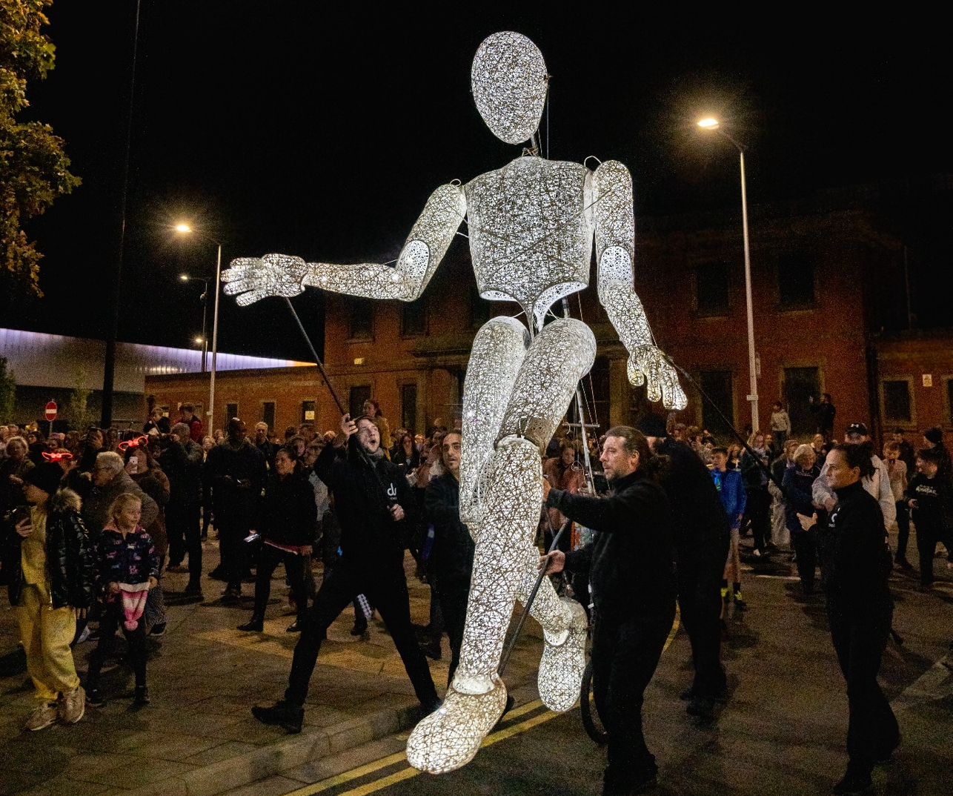
Global Streets - Sharing The Light (2022)
Person Specification

Essential
- Senior leadership experience at Board, executive or equivalent strategic level, with the ability to provide clear direction, support and constructive challenge
- Strong understanding of charity governance
- Experience of leading or chairing meetings, with the ability to facilitate effective discussion and decision-making
- Strategic thinking, with the ability to contribute to long-term planning and change management
- Data literacy, including the ability to scrutinise budgets, financial reports and organisational risk
- Ability to build effective relationships with senior staff, trustees, funders, local authority partners and other stakeholders
- Excellent communication and influencing skills, with the ability to act as an ambassador and advocate for Cast
- Commitment to Cast’s mission and values, including equity, diversity, inclusion, environmental responsibility and welcoming everybody
- Willingness and capacity to commit the required time to board meetings, preparation, key events and additional responsibilities associated with the Chair role.

Desirable
- Previous experience as a Board Chair or trustee, particularly within a charity, cultural organisation or publicly funded body
- Experience of promoting equity and diversity in leadership, or organisational practice
- Knowledge of the arts, culture or creative industries, and associated funding landscape
- Experience of promoting environmental responsibility
- Experience of working in complex stakeholder environments
- Previous Public sector engagement
- Financial or legal expertise
- Networks and connections that could benefit Cast through advocacy, partnership development or fundraising opportunities.
"Since joining the Board of Trustees at Cast in August 2024, I have been proud to support an organisation that inspires creativity, champions artistic excellence, and nurtures young people's interest in the arts. Drawing on my background in design and business, I am committed to helping shape the organisation's strategic direction, supporting its long-term growth, and enriching the experience it offers to audiences, artists, and the wider community. It is a privilege to contribute to a theatre that creates opportunities for emerging talent and ensures the arts remain accessible, inclusive and inspiring for future generations."

Eleni Shah, Board Member

How to Apply
Please send a letter of application (no longer than two sides of A4) or video lasting no more than five minutes, stating why you are interested in the role of Board Chair, including details of your relevant experience with reference to the person specification.
If there are any adjustments you need us to make to better support your access to the application process, please let us know. If you would like an informal chat please get in touch with Andrew on Andrew.burden@dclt.co.uk.
The closing date for applications is midnight on Sunday 6 September.
All applications will be considered by a Board Recruitment working group and those shortlisted will be invited to interview with a panel including a representative from the Cast Board, Arts Council England, City of Doncaster Council and Doncaster Culture and Leisure Trust. References will be requested if you are successful at interview stage.
The successful candidate will be offered a full induction, a period of handover to be discussed with the current Chair and will be recommended to the other Trustees in our Annual General Meeting on 27 November 2026.
Please send your application to: recruitment@castindoncaster.com
“As much as I try, I could never fully explain the impact the theatre has had on my life. I carried so much guilt and my heart was just broken into a million pieces but I just got up and did the very best I could every day for ten years. I truly don't know how this changed but it did and I started to heal a little in Doncastrian Chalk Circle (at Cast) a lot in The Cyclops and found peace with everything at the end of opening night in London.”
Participant in The Cyclops, a 2022 Cast co-production with The National Theatre
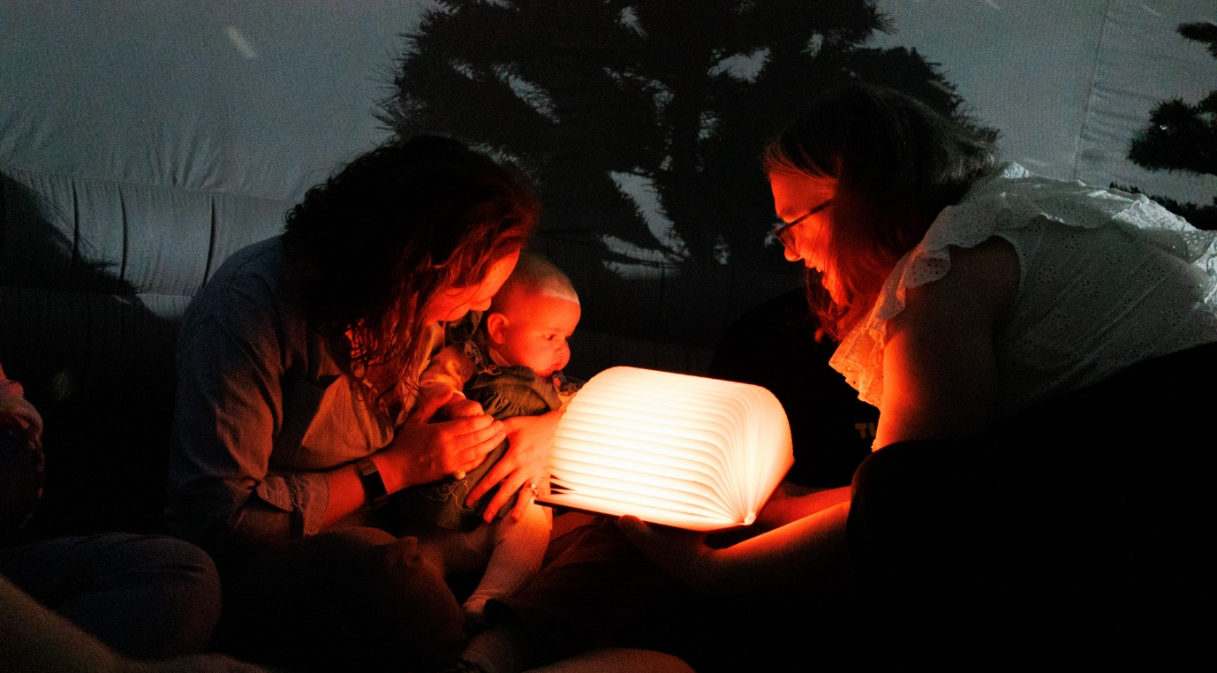
Sing, Sign & Sensory 2023
Your personal information
Your personal information will be held in accordance with the Data Protection Act 1998, and the General Data Protection Regulation 2018. You will not receive unsolicited paper or electronic mail as a result of sending us any personal information. No personal information will be passed on to third parties for commercial purposes.
When we ask you for personal information, we promise we will:
- only ask for what we need and not collect too much or irrelevant information.
- ensure that you know why we need it.
- protect it and insofar as is possible, make sure nobody has access to it who shouldn’t.
- ensure that you know what choice you have about giving us information.
- make sure we don’t keep it longer than necessary.
- use your information only for the purposes you have authorised.
We ask that you:
- give us accurate information.
- tell us as soon as possible of any changes.
- tell us as soon as possible if you notice mistakes in the information we hold about you.
We will share the information you provide with the members of the recruitment panel so your application can be assessed. These individuals will usually be identified in the information pack.

